How to detect, and remove, suspended (un-dissolved) chemicals and compounds from water

1. To detect un-dissolved, suspended materials in a water sample do either of the following processes:
2. Use a turbidity tube (can be found at many websites….such as:

<https://www.youtube.com/watch?v=AdfJ1D3An3Q>

and

<https://www.gvsu.edu/wri/education/instructors-manual-turbidity-10.htm>)

1. Compare your test water sample to known, calibrated turbidity scales (can be found at:

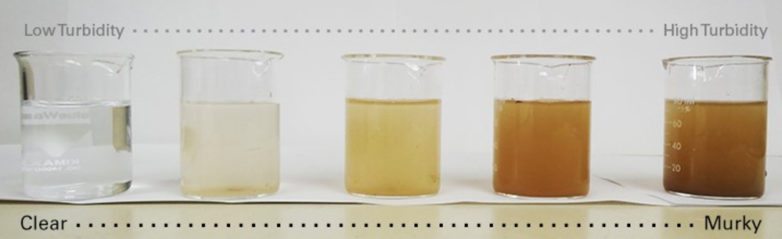

<https://blogs.worldbank.org/water/how-test-water-quality-here-are-some-low-cost-low-tech-options>

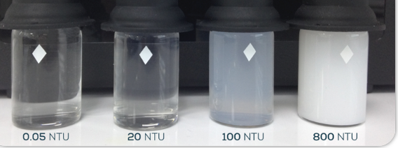

<http://www.clevelandwater.com/blog/understanding-turbidity-and-why-it-matters>

1. To remove un-dissolved/suspended materials from water—using Alum

Procedures:

1. Fill a cup (50-75ml) with sample water
2. Add (about) ¼ teaspoon of Alum and stir gently for 5-10 seconds
3. Check water for signs of clearing--- the Alum is working. If there is no clearing in the water, add another ¼ teaspoon of Alum and continue stirring.
4. The water should be getting clearer…. Note the materials that have settled to the bottom of the cup.

(a good reference and article on using Alum can be found at)

<https://www.scientificamerican.com/article/drinking-water-cleanup/>