Experiment Challenge
Investigate and determine the HARDNESS of various water samples

Groundwater and water from streams and lakes are solutions-they are mixtures of water and dissolved minerals. Even the purest of natural water contains some dissolved minerals, most commonly called “total dissolved solids”, or TDS. TDS is the sum total of all of the dissolved things in a given body of water. It's everything in the water that's not actually water.
Dissolved minerals give water it’s “hardness”; i.e. “hard” water is water with a lot of dissolved minerals like calcium and magnesium.
The term “hard” water refers to the fact that the water is HARDer to create soap suds; and conversely, “soft” water creates soap suds more easily because it has less dissolved minerals in it.
Dissolved minerals in water samples (hard water) hinders the formation of soap suds.
Dissolved minerals in water samples (hard water) often creates white spots and streaks and build up/scales on dishes.

visuals of different water samplse with different levels of “hardness”: found at:
https://www.youtube.com/watch?v=p6w6JAXAsRY

similar labs found at:
https://www.education.com/science-fair/article/design-ways-test-water-hardness/

Student Challenge
Investigate and determine the HARDNESS, the dissolved solutes, in a variety of water samples

PART A- learn how to determine water hardness

MATERIALS
- water sample containers—small bottles which have lids; or test tubes with corks
- 1T (1 tablespoon) distilled water (15 ml)
- ¼ t (1/4 teaspoon) salt, Epsom salt
- spoon
- eyedropper
- dishwashing liquid soap

PROCEDURES
1. First you will be testing the most pure water you can find ( i.e. the most “soft” water you can find; the water with few/no dissolved minerals); To do this, use distilled water. Place 1T distilled water into a sample container.
2. With the eye dropper, add one drop of the dishwashing liquid. Secure the lid and shake the closed sample bottle for about 30 seconds. Measure, or somehow record the height of the suds above the water (or how much suds you got). REPEAT a few times to get a good average.
3. Now test distilled water to which you’ve added salt that will dissolve in the water—this will be a a comparison to see how water with dissolved substances (“hard” water) reacts differently that “soft” water (water with very little, if any, dissolved substances—like distilled water). Repeat steps 1 and 2 from above
3. Record data in a simple data chart
4. Summarize and report findings

PART B- Have students determine the relative water hardness of various water samples----teacher and students can bring in water samples to use.

FYI
- water hardness measurements:
“moderately hard water” (between 61-120 mg/L)
“hard water” (121-180 mg/L”
Info taken from:
https://westfordma.gov/DocumentCenter/View/1414/Water-Hardness-PDF?bidId=

- Water hardness around the country

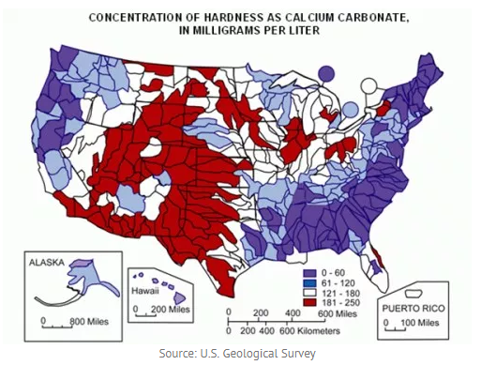
Map found at: https://preclaboratories.com/water-hardness-science-experiment/

