**Important background information for teachers**

**WHERE TAP WATER COMES FROM**

1. In the U.S. there are an estimated 168,000 *public water systems*, water departments) serving close to 90% of Americans, the remaining population gets their water from private wells.

*Public water systems* get their water from one of two locations: surface waters (streams, rivers, lakes) and groundwaters (water beneath the surface such as aquifers)

The majority of people that use *public water systems* have drinking water that comes from surface waters. In general, well-populated metropolitan areas get their drinking water from surface water supplies, whereas small, rural areas tend to rely on groundwater for their drinking water. <https://www.cdc.gov/healthywater/drinking/public/water_sources.html>

1. When surface and ground waters become severely polluted they are referred to as ‘impaired waters’ (***impaired*** waters are too polluted or otherwise degraded to meet water quality standards).

By far the vast majority of source waters in America are classified as impaired. For example:

(a) of the lakes, reservoirs, and ponds in America that were assessed, 70.7% were declared impaired;

(b) almost 86% of the Great Lakes shoreline was assessed, and 97.7% was declared ‘impaired’.

<https://ofmpub.epa.gov/waters10/attains_nation_cy.control>

1. GROUNDWATER:

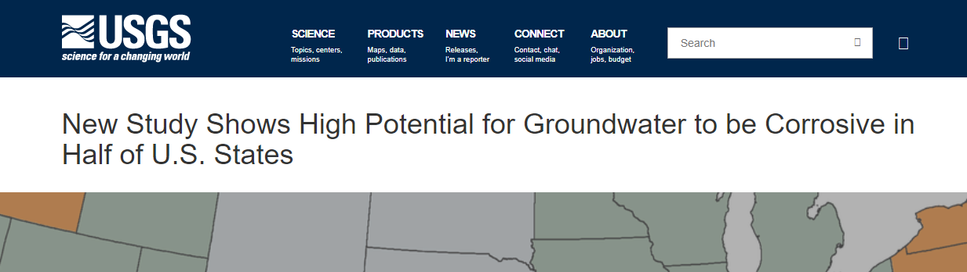

<https://www.usgs.gov/news/new-study-shows-high-potential-groundwater-be-corrosive-half-us-states-0>

**WATER TREATMENT PROCESES**

1. Bellingham’s water treatment process found at:

<https://www.cob.org/services/utilities/Pages/water-treatment.aspx>

1. The processes, or steps, employed in Conventional Water Treatment facilities:

* screening out larger debris and particulate matter;
* adding coagulation and flocculation chemicals, then providing sedimentation
* filtration (for example, sand and/or charcoal filtration)
* disinfection most commonly with chlorine or chloramine or a combination of both
* water released for ‘distribution’—into pipes to be delivered to the public

1. Often, conventional water treatment plants do not have the upgraded equipment or trained personnel needed to remove today’s vast assortment of toxic contaminants, partly due to expense, partly because they don’t have to. Contaminants that are not regulated are also not required by law to be monitored or tested for---they get basically ignored by water treatment personnel. Consequently many contaminants pass right through treatment facilities directly into public water supplies.

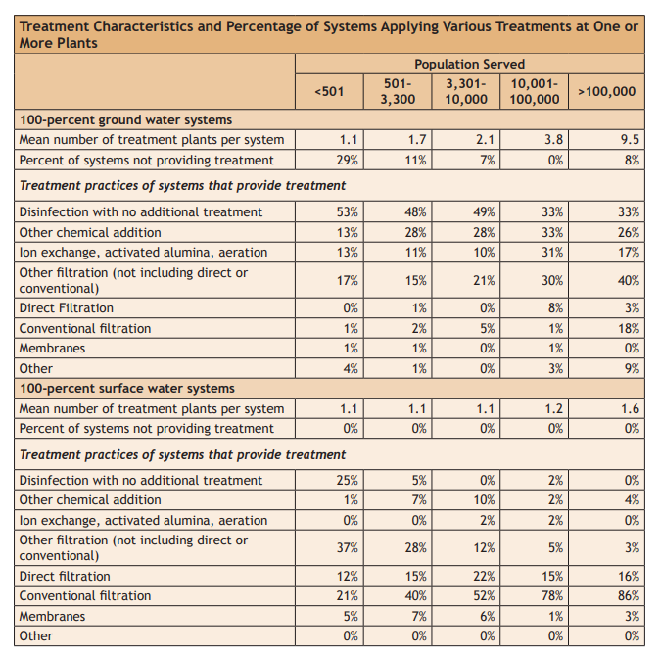

<https://nepis.epa.gov/Exe/ZyPDF.cgi?Dockey=P1009JJI.txt>

1. Concerns about water treatment plants

Water treatment facilities unavoidably **create and add** cancer-causing contaminants (called disinfection by-products) to public water supplies from the disinfection processes they use.

The chemical properties of many contaminants make it difficult to remove them from water using conventional processes …..For example, the EPA has approved three treatment methods for removing nitrates/nitrites from water: ion exchange, reverse osmosis and electrodialysis—none of which are included in conventional processes, and the majority of treatment facilities do not have nor use these more complex and costly processes.

The unwanted residual waste material from water treatment, the settled-to-the-bottom ‘sludge’ is becoming a real problem and human health concern. Studies in 2004 reported approximately 60% of the produced sewage sludge in the country is being disposed of by spreading it on land. Many feel that putting sewage sludge on land is a health and environmental disaster.

**PUBLIC DRINKING WATER**

**Regulations**

Number of water contaminants identified in a USGS study: **337**, 17% are regulated

1. Regulated vs Unregulated [Nearly two-thirds of the 315 chemicals found in the nations’ drinking water over the last five years—a total of 201**—**are**unregulated.**Among the unregulated contaminants detected in water supplies, 168 have been linked to cancer, 54 to reproductive toxicity, 67 to developmental toxicity, and 35 to immune system damage.](https://www.ewg.org/tapwater/#.WlP0gainGUk)

<https://www.ewg.org/tapwater/#.W7KoFWhKiUl>

**Water Quality Reports**

1. **Environmental Working Group (**EWG's) Tap Water Database – the most complete source available on the quality of U.S. drinking water, aggregating and analyzing data from almost 50,000 public water utilities nationwide.

<https://www.ewg.org/tapwater/#.W7FSZ2hKiUk>

1. **EPA’s Consumer Confidence Report** (CCR), also known as an annual drinking water quality report from your water supplier

<https://ofmpub.epa.gov/apex/safewater/f?p=136:102>::::::

1. City of Bellingham, water quality report, 2017

<https://www.cob.org/Documents/pw/lw/CCR_2018_web.pdf>

**CONCERNs**

1. Carcinogens in drinking water

81% of tested water systems across America had contaminants linked to cancer, most of which are not factored into water quality assessments. Of the more than 250 detected water contaminants, 93 have been linked to an increased risk of cancer.

<https://www.ewg.org/research/water-treatment-contaminants#.W7KqUmhKiUl>

** More about carcinogens in drinking water at:

[www.uncoveringdata.net](http://www.uncoveringdata.net)

1. Harmful Algal Blooms (** see separate document on this topic)

Green pond scum--- algae blooms--- blue green bacteria, (cyanobacteria), and their toxins (cyanotoxins,)

There are NO EPA regulations for monitoring or testing for these toxins AND no state in the U.S. [reported conducting routine monitoring for microcystin (the most common cyanotoxin)](https://www.epa.gov/sites/production/files/2014-09/documents/asdwa_drinking_water_hab_survey_summary.pdf)

1. Endocrine Disrupting Chemicals



<https://endocrinedisruption.org/>