**Lettuce Seeds as Bioindicator to Assess Water Quality**



The EPA has used well documented organisms such as duckweed, Daphnia, and lettuce seeds as biological indicators of poor water quality.

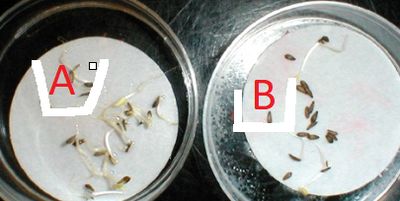

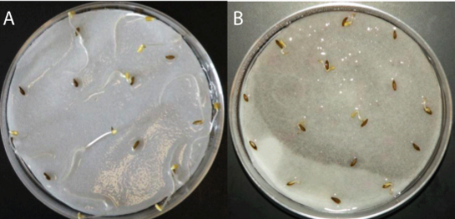

The EPA has used well documented organisms such as duckweed, Daphnia, and lettuce seeds as biological indicators of poor water quality.

Bioindicators are inexpensive, non-pain sensitive organisms students can use to detect water quality deterioration, similar to the way canaries were used to detect toxic gases in coal mines.

Current methods used by water departments to detect water contaminants are typically expensive, and require costly laboratory testing and skilled technical expertise.  Many communities and their water treatment plants cannot afford the equipment, human, and technological resources needed to filter out contaminants, especially the contaminants of emerging concern.

Bioindicators are organisms that can be used as early-warning indicators of drinking water deterioration. Just as canaries were observed for signs of impending hazards, bioindicators can be used as simple, low-cost monitors of water quality.

The Environmental Protection Agency uses data from tests with the common lettuce seeds (Lemna gibba or Lemna minor) to develop data on water toxicity of test substances. So too can students become contributing Citizen Scientists as they use lettuce seeds to collect and monitor water quality data.

In this lab, the use of lettuce seeds does not result in the detection or identification of a specific water contaminate, but rather, observed changes with the sprouting and development of the lettuce seeds suggest water quality issues--- raising a red flag that more serious/thorough testing should be pursued.

(information adapted from: <https://www.mobot.org/jwcross/duckweed/duckweed.htm> )

PROCEDURES

Investigate: How is lettuce seed (Lactuca sativa) germination and growth is affected by the type of

water grown in.

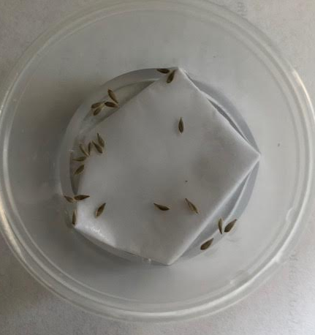

Containers, each with 15 lettuce seeds covered in enough water to keep hydrated

1. control conditions = lettuce seeds growing in spring/pond water
2. variable conditions = lettuce seeds growing in tap water; bottled water; distilled water

With the exception of the type of water grown in, expose all containers to exactly the same growing conditions such as temperature and sunlight.

OBSERVATIONS AND MEASUREMENTS TO INCLUDE (over 3-5 dayperiod)

1. # of germinating seeds (or percent sprouting)
2. Color and size radicles



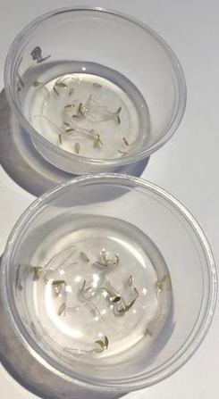 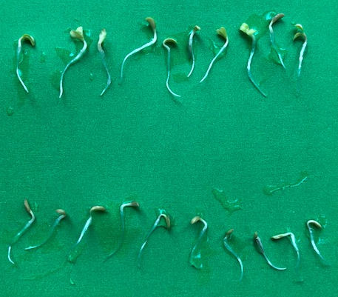

NOTE: It has been suggested that lettuce seeds be soaked in a 10% bleach solution for 20 minutes, then rinse five times with deionized or distilled water--for killing fungal spores that can interfere with seed germination.

<http://ei.cornell.edu/toxicology/bioassays/lettuce/RefTest.html>

**Useable Information Found At:**

1. Environmental Inquiry

Authentic Scientific Research for High School Students

<http://ei.cornell.edu/toxicology/bioassays/lettuce/>